Skywalker X-8 Installation Manual

Thank you for Purchasing the Sky- walker X-8 Plane. The skywalker X-8 is designed for First-Person-Vision(FPV) application specifically.

Technical parameters
Wingspan：2120mm weight：880G motor：2820 KV730 speed regulator：60A Servo：17G battery pack：4S8000MAH propeller： 12X6~13X8

Take-off weight ：3200G
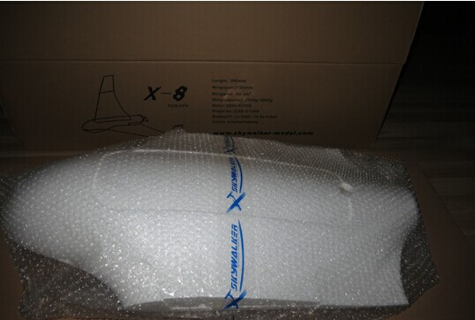
KIT version configuration：Fuselage, wing, winglet , tube, accessories bag, sticker

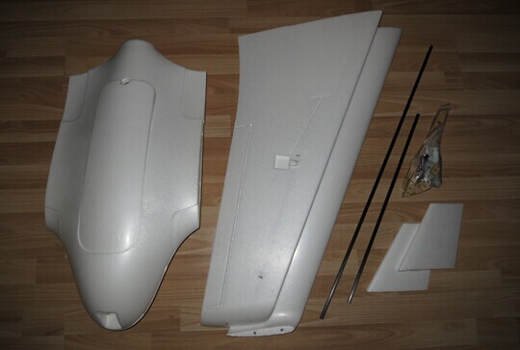

Parts Listing
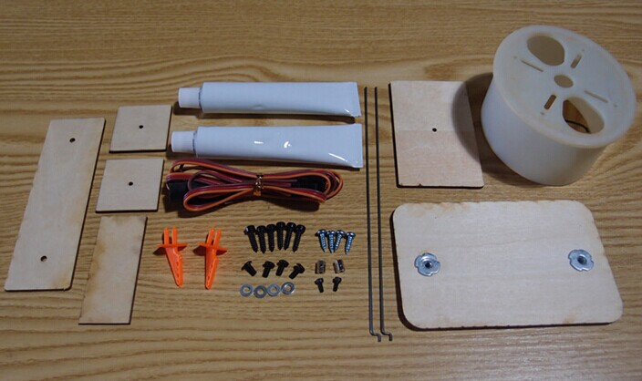

Assembly
Glue the winglet layers, spread the glue evenly over the wing and both sides of the layers ( the layer marked with T board belongs to parts of the main wing )
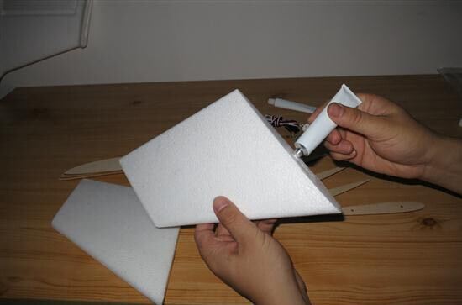

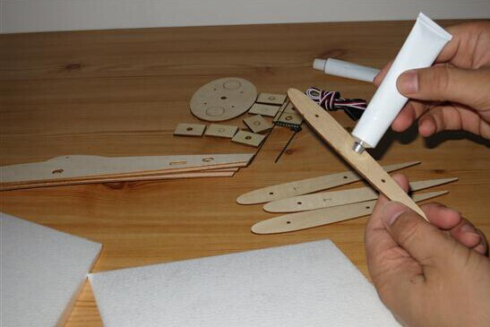

Wait for 5 minutes to allow glue to dry until it is non-sticky, then they can be glued in alignment ,

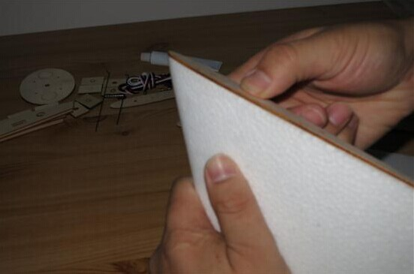

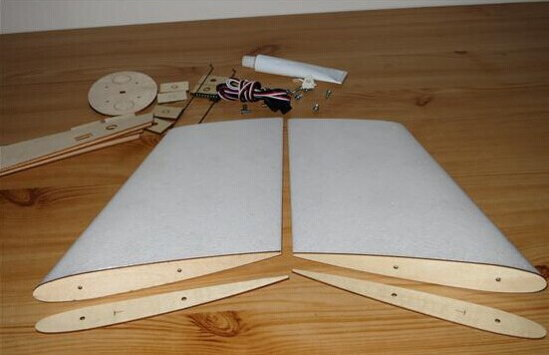

Glue the hatch magnets , after compressing the magnet tightly, fix them with CA glue.

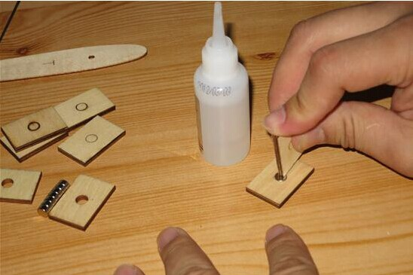

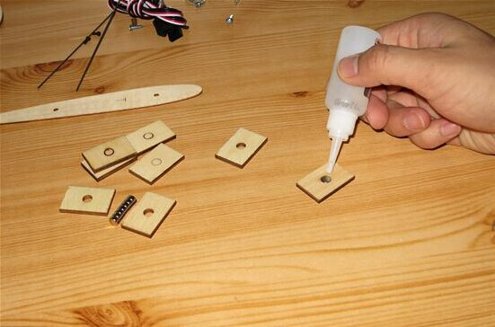

Glue the wood chip onto the hatch and fuselage, pay attention to the direction of SN of the magnetic pole

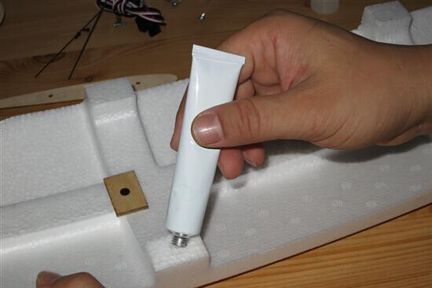
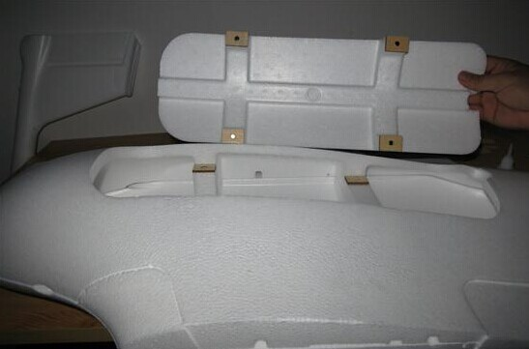

After gluing, put it together and inspect the mounting spacing

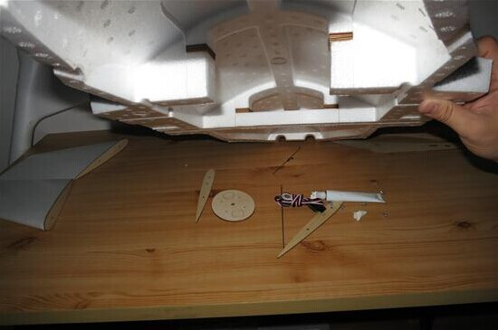

Glue the servo, please choose the standard servo provided by skywalker or servo with moment more than 2.5 KG
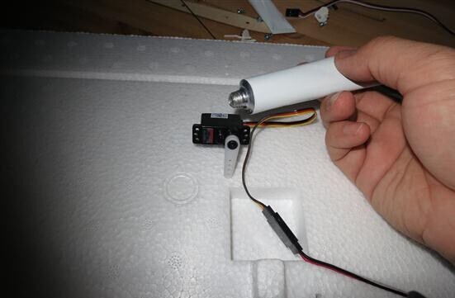

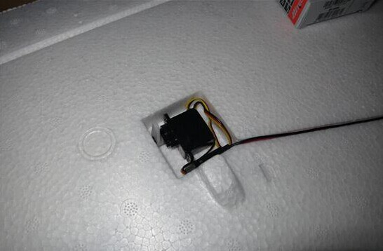

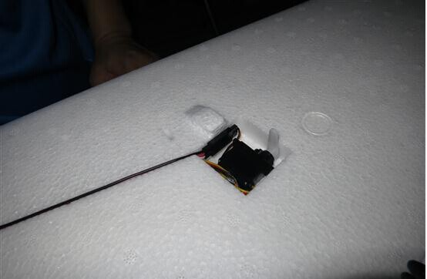

Glue the rudder horn, spread the glue evenly and wait for its dryness, then Glue the rudder horn

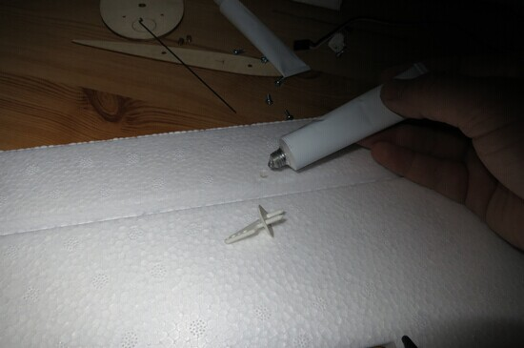

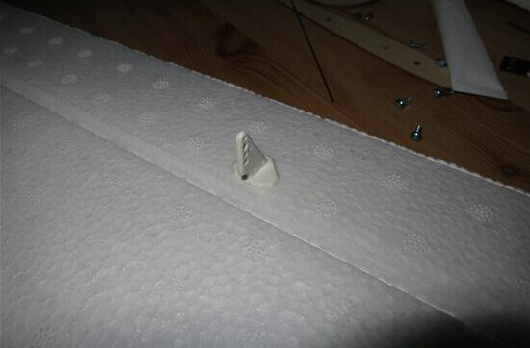

Power on the servo and place it in the mid-position , then lock the regulator screw, tighten the steel wire. And shorten the extra length of the wire.

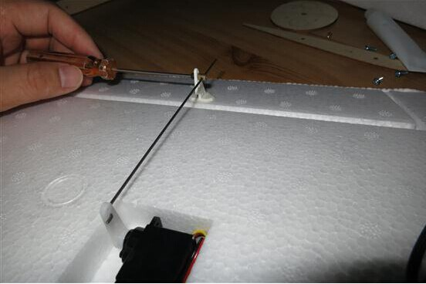

Glue the fixed layer of the winglets, please be sure to spread the glue evenly and wait until it is completely dry, afterwards you can glue the layer.
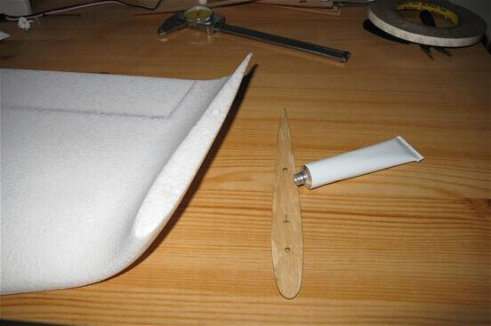
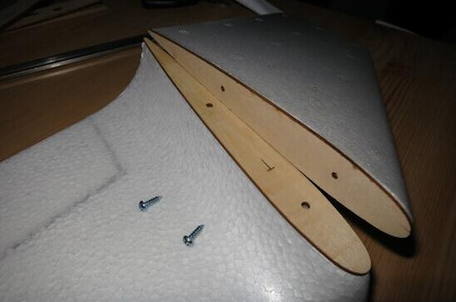

Cut out the pre-reserved slot on the aileron only about 1,5 mm wide by a new blade
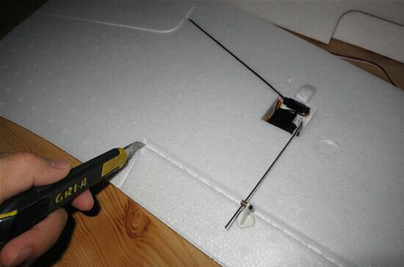

Wing plate bonding, please to smear evenly on all surfaces, please not to spread the glue over the tube slot !
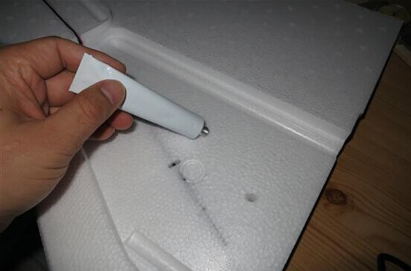

Settle the extending line in the line slot previously and spread the glue evenly over the plate.
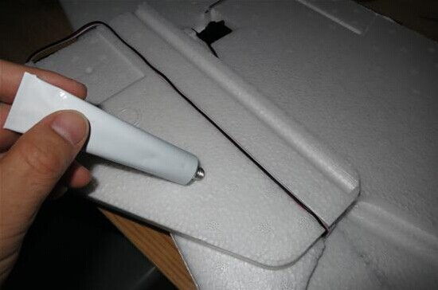

Wait for the two planes' dryness, later spread some glue over the vertical planes, and then fix and flatten them.
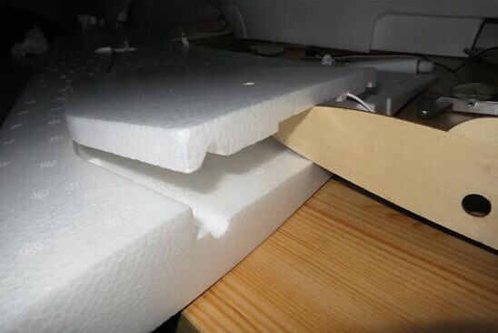

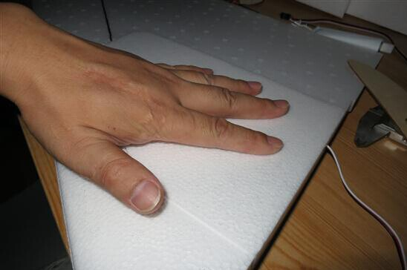

The side plate bonding: spread the glue on both sides of the plate
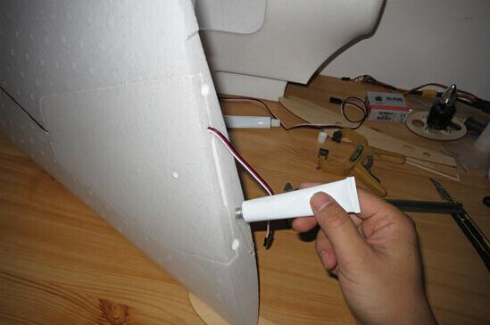
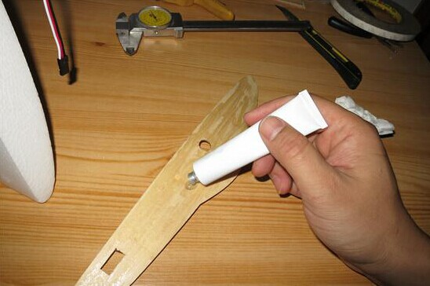

It is recommended to insert the tube into the wing to guide the butt plate, which is more accurate.
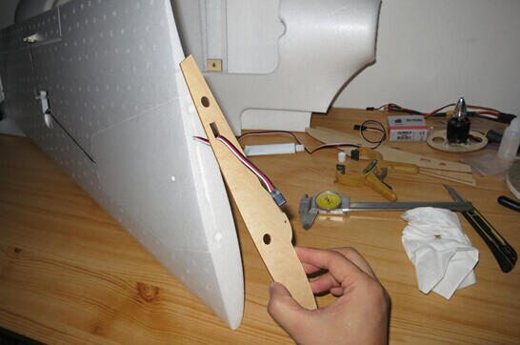

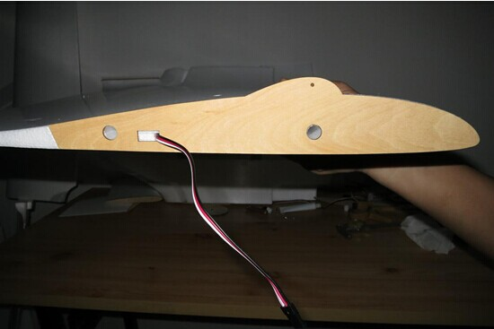

The line slot of early product also need to be widened to let the the extending line with plug directly into the fuselage.
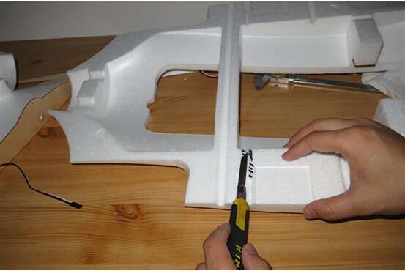

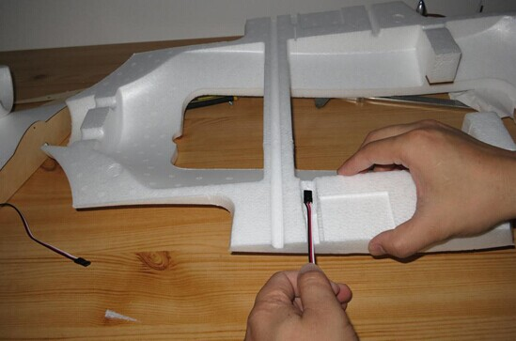

Fix the motor, and cement it to the fuselage in advance, you can also first fix the layer board base, and afterwards install the motor.
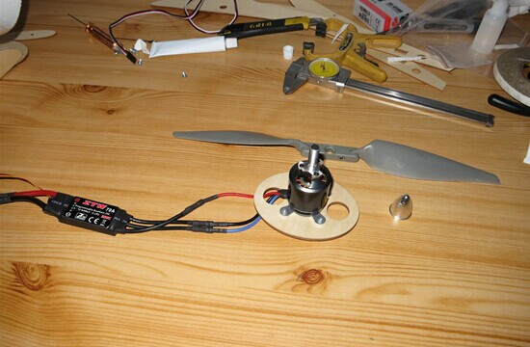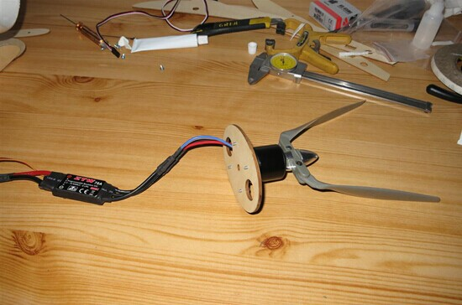

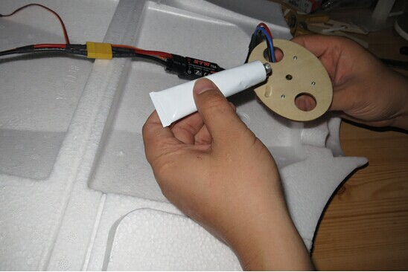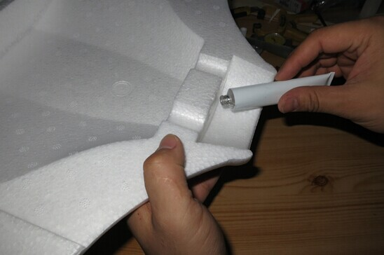

Spread the glue on both sides of the fuselage, note:please avoid the tube slot!
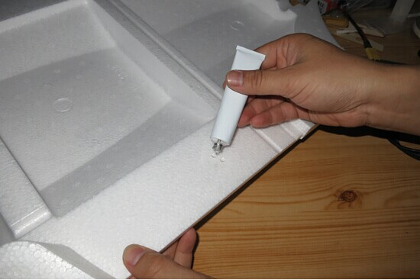

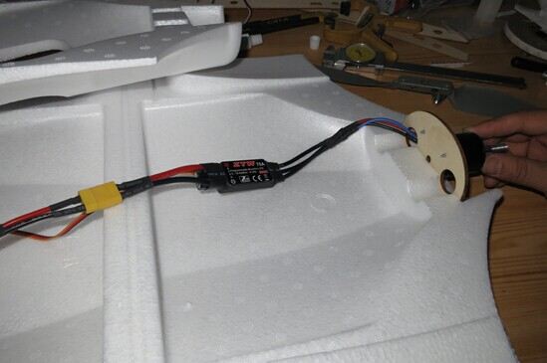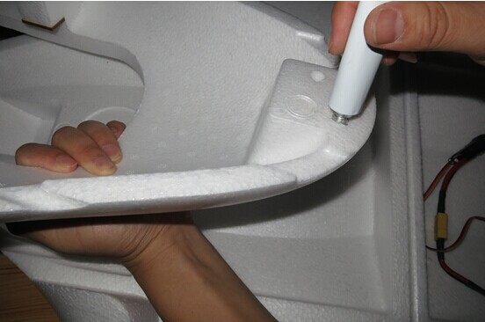

After the two sides is dry, align and glue them
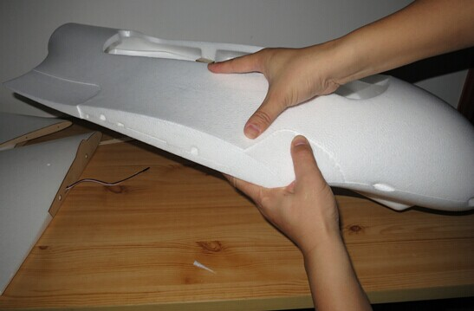

And then glue the butt plate of the fuselage.
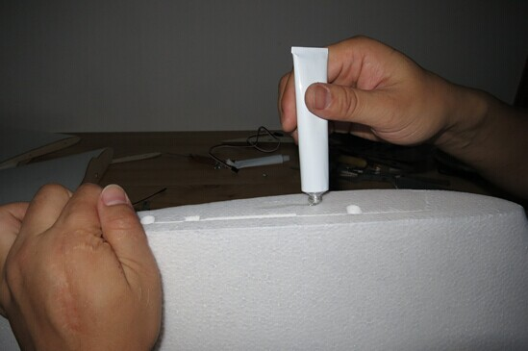

Still use the tube as a guide, align and glue it.
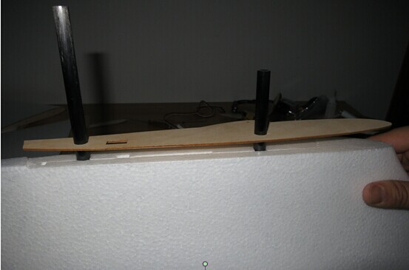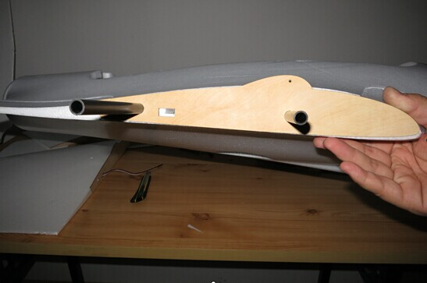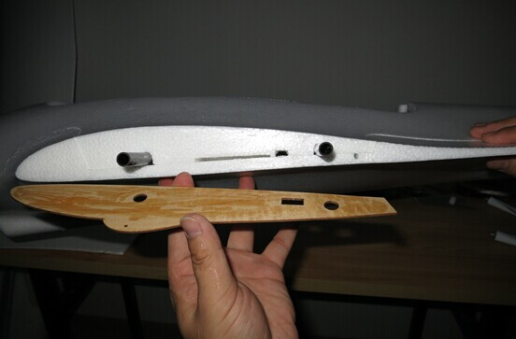

After gluing, you can butt the wing to make a trial of the accuracy, insert the extending into the fuselage through the line slot.
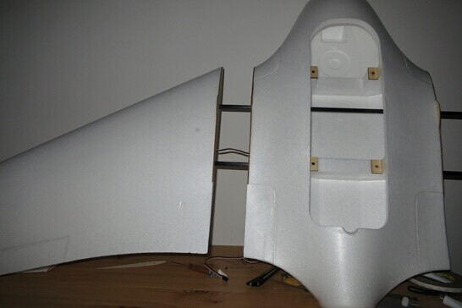

We can see the butt is perfect.
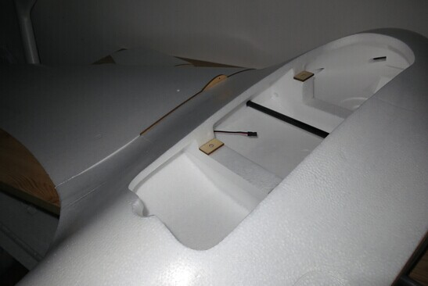

As the airframe is designed to be very wide, you can easily put your FPV equipment down, and separate the transmitter and receiver.
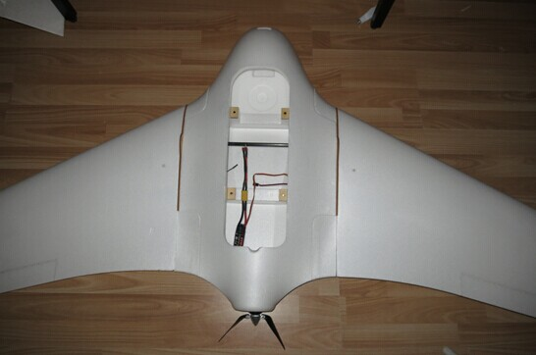

Fixing the wing is also very simple, just a screw, of course, if you don't trust this construction, you can also use a nut to butt.
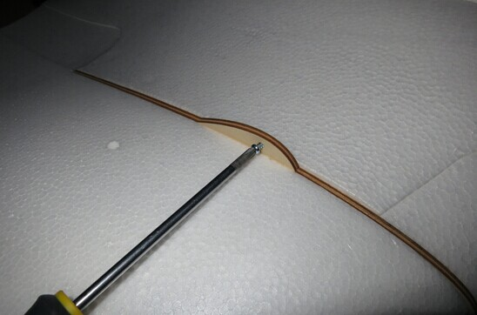

Fix the winglets with two 3 x8 screws, with the purpose of a long- term usage of the layer plate, it is suggested that consolidating the screw hole with CA glue before twist the screw.
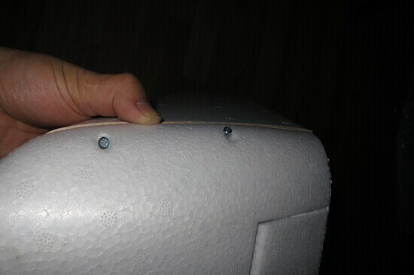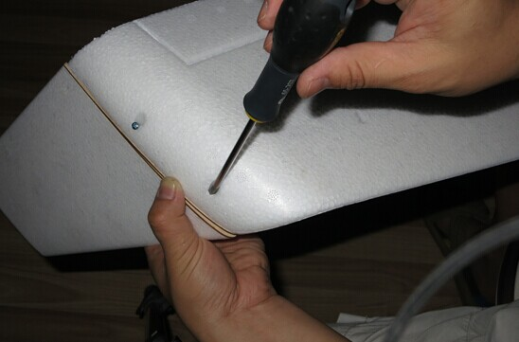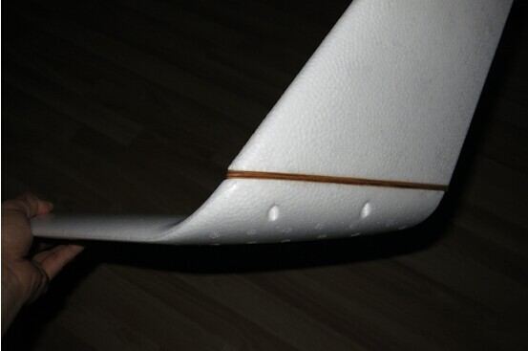

If you glue the motor frame previously, you can fix the motor now.
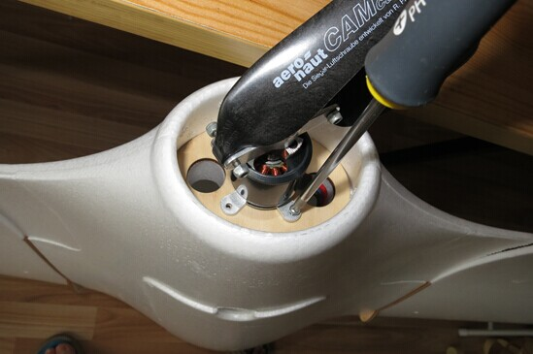

We suggest you use brand quality propeller of CAM or APC .
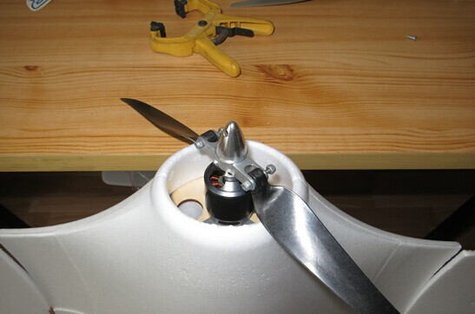

We reserved the mounting positions of CCD holder and GOPRO
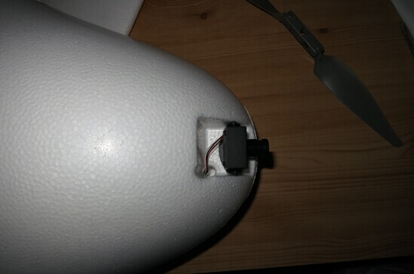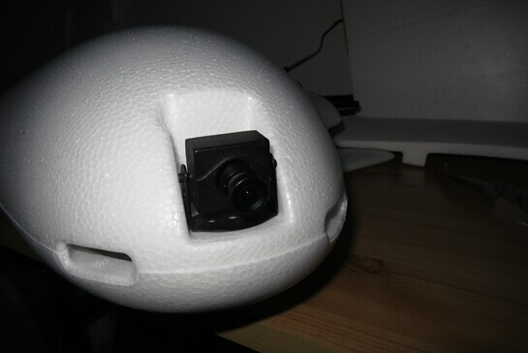

You need to open a round hole in the corresponding position of the GOPRO's lens. And cut out a bevel to ensure not to obscure the vision of the wide-angle lens.

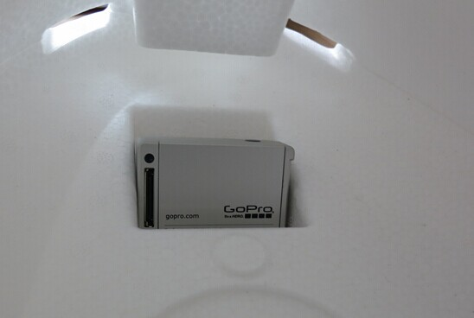

The position of the center of gravity of X - 8 is 440 mm away from the nose , 5 mm correction interval in front and at the back of it.
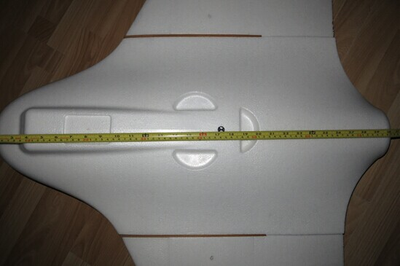

The installed machine can be decomposed into small parts, which is easy to carry.
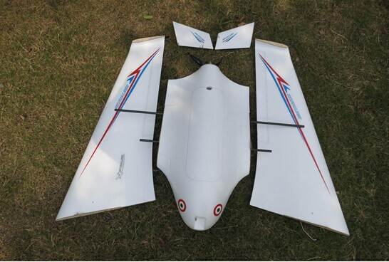

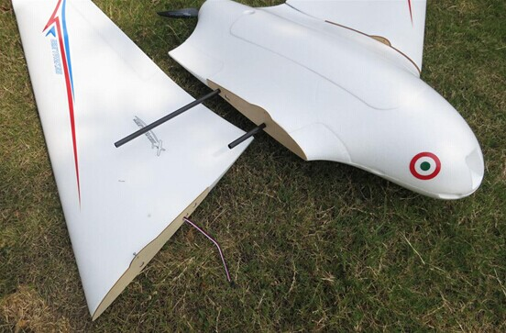

Done!
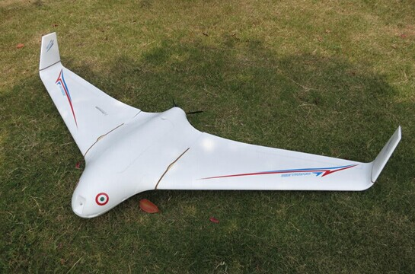

Finally, Please note that , control X - 8's flight speed within 85 km/H. If you need a high speed flight, please strengthen wings. please control the machine load within 3200 g, if exceed the limit, please strengthen wings. Thank you again for choosing skywalker series products. If there are technical problems or suggestions, please email us for consultation. Or consult your local dealer.

